ActaVet dog biscuits.
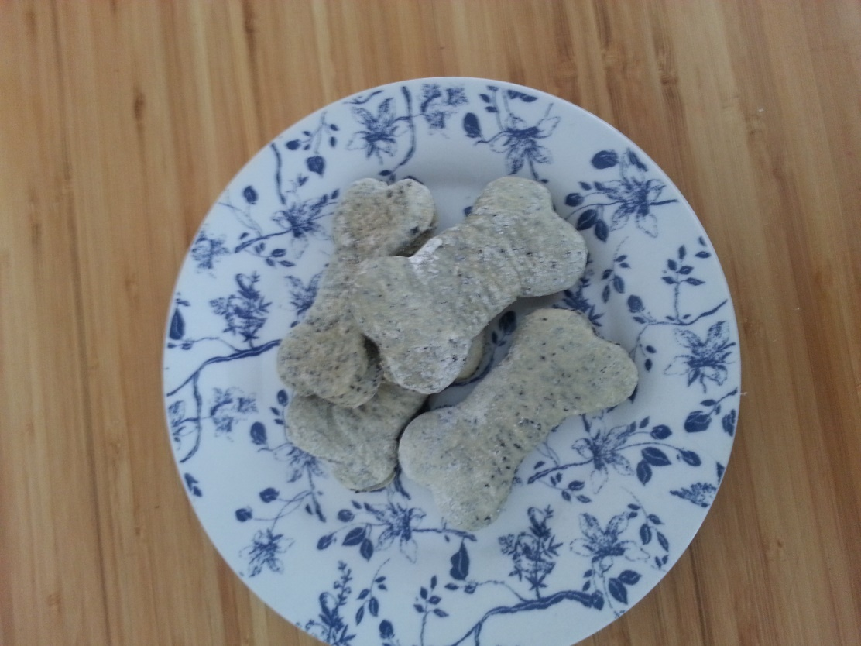
Dog biscuits are a great treat for your pet. Charcoal dog biscuits can be administered for dogs with bad breath or flatulence.

Charcoal Biscuits for Bad Breath
The charcoal biscuits for dogs (or cats!) contain activated charcoal and can be administered if your pet has this problem.
Typically, the breath of dogs is not particularly pleasant, but may get worse if the dog ages or suffers from a number of health problems such as:
- Teeth and gum disease
- Liver and kidney damage
- Diabetes
- Stomach problems such as indigestion
- Tumours in the gastrointestinal or respiratory tract
While these conditions need proper treatment, you can reduce the problem of bad breath with carbon biscuits.

Benefits of Activated Charcoal
The activated charcoal can be used in a number of instances, most frequently in cases of bad breath and flatulence.

Preparing Activated Charcoal Biscuits
If you want to enhance the odour absorbing powers of the treats, you can add parsley or peppermint to the mix, as these ingredients are known to reduce bad breath as well. Use dry parsley or peppermint leaves. All these ingredients are safe for the dog.
The charcoal treats will also be a rich source of fibres, which can reduce problems such as diarrhoea .
Meanwhile, you should get to a vet and establish if the bad breath is caused by an underlying medical condition.
(from https://www.vetinfo.com/charcoal-dog-biscuits-for-bad-breath.html)

Actavet dog biscuits
These basic biscuits can be customized to cater to your canine’s palette
Ingredients
2 ½ cups whole wheat flour (substitute regular flour or oats if your dog is sensitive to wheat)
8 - 10 scoops ActaVet (can adjust to taste)
1 tsp. salt (or less)
1 egg
2 x Beef or chicken stock cube or granules (can substitute beef or chicken broth/stock)
½ to 1 cup hot water
Optional: Add bacon or chicken broth, eggs, oats, liver powder, wheat germ, shredded cheese, bacon bits, to (your dog's) taste – but remember that you may have to store biscuits with cheese/bacon in the fridge and only for 1 week. Otherwise, store in an airtight container in a cool dry place up to a month.
Directions
Preheat oven to 180 degrees
Dissolve stock cubes in ½ of the hot water, then cool
Add remaining ingredients, adding additional water to make a firm dough.
Knead dough until it forms a ball (approximately 3 minutes)
Roll dough until 1cm thick
Cut into slices or bone shapes (you can purchase a bone shaped cookie cutter to make shapes with)
Place dough pieces on lightly greased cookie sheet
Cook for 30 minutes at 180 degrees C.

